**Mechanical Liquid Level Gauges  
Krueger Type D**[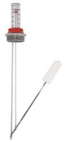](http://www.ksentry.com/images/liquid_level_gauge_diagram.jpg)

The At-A-Glance Type D Liquid Level Gauge is a reliable, swing arm type tank gauge used for measuring all types of liquid levels. This sight gauge’s simple mechanical design promotes durability, minimal upkeep, quick installation, and easy/inexpensive repairs.  
 This liquid level gauge is custom made in house to fit your tank. We can accommodate any size tank from 6 inches to 12 feet in depth. We can also account for double walls and pipe risers, and we offer multiple materials of construction to accommodate nearly any type of liquid.

**King Gauge**

* Molded Float is impervious to petroleum products.
* Tangle-Free "Solid Link" hinge withstands rough handling.
* Available to fit both Vertical and Horizontal tank applications.
* Large, easy-to-read, plastic vile includes UV inhibitors, and is the most break resistant on the market.
* A new flanged vial provides double seal including exterior o-ring.

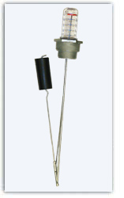

**King Vent Alarm Gauge Combo**

* Molded Float is impervious to petroleum products.
* Tangle-Free "Solid Link" hinge withstands rough handling.
* Durable cast iron with corrosion-resistant powder coating.
* Available to fit both Vertical and Horizontal tank applications.
* Large, easy-to-read, plastic vial includes UV inhibitors and is the most break-resistant on the market.
* A new flanged vial provides double seal including exterior o-ring.

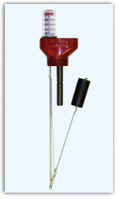

**Fill Alarm**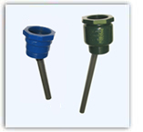

* Sizes to fit most popular above-ground and in-ground tanks
* Durable cast iron with corrosion-resistant powder coating
* Whistles while tank is being filled; stops whistling when oil has reached safe capacity level
* Patented whistle design is up to 10 dB louder than conventional designs (U.S. Patent 7497185)

**Mechanical Liquid Level Gauges  
Jarhead**

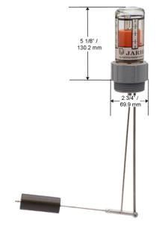

For use with oil, waste oil, diesel fuel, antifreeze, water and other fluids with a low flash point. Available in 1 ½ “-2” N.P.T threads.

**Black Night**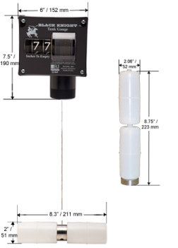

Numbers decrease as fluid level lowers indicating how many inches are left until the tank is empty. For use with oil, waste oil, diesel fuel, antifreeze, water and other fluids with a low flash point. Measures from 99”-0”. Available in 2” N.P.T. threads.

**Red Fox**

Numbers decrease as fluid level rises indicating how many inches are left until the tank is full. For use with oil, waste oil, diesel fuel, antifreeze, water and other fluids with a low flash point. Measures from 99”-0”. Available in 2 inch N.P.T. threads.

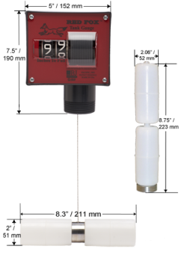

* Super strong Kevlar string for smoother operation.
* Eliminates the need to stick the tank, saving time and money.
* Unique polypropylene double float design.
* Measurement readings available in gallons or inches
* Easy-to-read window has an anti-fogging vapor barrier.
* Most accurate gauge of its kind.
* Large numbers allow you to check level from a distance.
* Installs easily in 1 ½” and 2” openings.
* Accommodates tank depths to 108”.
* Used in a variety of liquid products
* Perfect for will call accounts
* The standard in lube oil and waste oil tanks.

**Scully Golden Gauge  
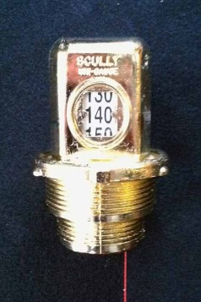**

**Mechanical Tank Gauges**

**Simplex Tank Gauge**

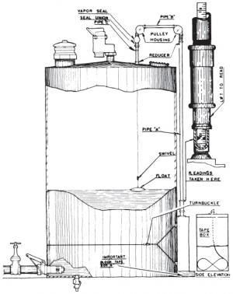

Used for measuring liquid level in aboveground storage tanks. Best suited for vertical tanks over 12 ft. high. Gauge readout by tape which passes over an indicator mounted at 3 ft. height on the side of the tank. Activated mechanically by a float that rests on the liquid level. Float is connected to a cable that runs up through the top of the tank, across two pulleys, and down the side of the tank to the indicator position.

**Clock Gauge**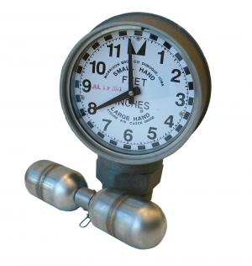

For measuring liquid level in aboveground storage tanks. Gauge mounts on top of tank and is activated by a float connected to a cable. Readout is on a 12 hour clock face. Small hand = feet or meters Large hand = inches or centimeters. Gauge can be read 20-30 feet away to within 1/8 ". Maximum measurement is 12 ft.

**OPW 200 TG AST Mechanical Tank Gauge**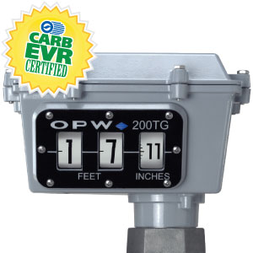

The OPW 200TG Tank Gauge is designed for reading liquid levels in horizontal or vertical aboveground storage tanks. The 200TG Tank Gauge provides an accurate numerical counter readout, eliminating the need for any on-site manual gauging.

**Electronic Gauging**

**Electronic AST Mechanical Tank Gauge  
1018**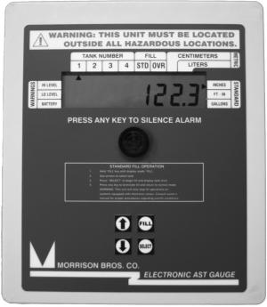

Monitors 1 to 4 aboveground storage tanks per console. Each gauge can be located up to 1000 ft. from the console. Can measure tanks up to 35 ft. in height, including vertical or horizontal cylindrical tanks and rectangular tanks. Accurate to 0.1”. Choose Feet-Inches, Inches or Gallons. Metric readout can also be selected as an option on the console.

**The ACU Gauge**

* The ACU Gauge is a float type sensing device good from 0"-60" deep tanks and accurate to 1/10" of an inch.
* It has a 3.5 digit backlit display. The unit runs on either a nine volt lithium battery, or it can run off of the remote unit's power source.
* The display has a push button activation with a battery saving automatic shutoff.
* Unit is contained within a weather proof housing. It is semi waterproof (cannot be submerged), and is good from 30 to 140 degrees Fahrenheit.
* Standard auxiliary output jack with high quality gold plated connections.
* The Remote Display is an optional add on that retains all of the same properties as the ACU Gauge itself.
* It also offers remote capability, wall cube power, Hi/Lo level adjustable alarms, and an optional 4-20 mA output.

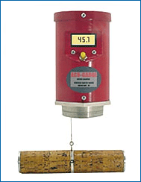

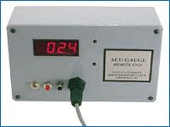

**TMS 3000**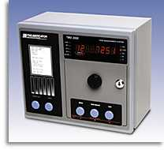

A truly low cost, high performance solution designed to meet all of your environmental compliance and inventory management needs. Complete with every feature you need, the TMS 3000 has a simple, user-friendly interface.  
Extremely flexible, modular system architecture. Completely field configurable and upgradeable.  
Support for up to 12 precision, dual float magnetostrictive level probes.

**Electronic Tank, Sump, Interstitial Monitoring  
Model ATA Tank Monitor  
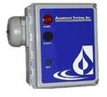**

An intrinsically safe tank monitor can be used to monitor high or low levels and/or leak detection. Available in 115 volt. Meets NEMA 4 requirements. One and two channel panels available.

**Series RAP Remote Annunciator**

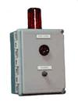

Can be remotely mounted to announce tank conditions. Used in conjunction with the ATA tank monitor.

**AMS Alarm Panels  
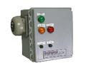**

Can be remotely mounted to announce tank conditions. Used in conjunction with a series of ATA tank monitors.

**MC Box Fluid Management System:**

**Control Fuel Consumption**

[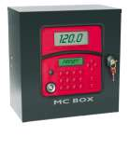](http://www.piusiusa.com/sites/piusiusa.com/files/MCBOX_system_2.jpg)

Multi-user control panel with PC connection. PIUSI has developed a complete system to enable the control of the fuel consumption. The MC system consists of a multi-user panel contained into a protection box, and dedicated software to be installed in a PC. The control panel can manage directly: switching ON and OFF the pump, recognize authorized users by means of I-button key or password, preset the quantity to dispense, a pulse meter, and the possibility to switch off the pump in case of low level input. The software arranges dispensing data for analysis and print out. Data can be sent direct to a PC via cable (see PC interface) or via an electronic key with memory (see Kit Key).

Technical Features:  
Panel with dual display, keyboard and I-button reader.  
Controls up to 120 users.  
Calculated consumption of each individual user.  
Local memory of last 255 operations.  
Possibility of vehicle identification.

**Gasboy TopKat**

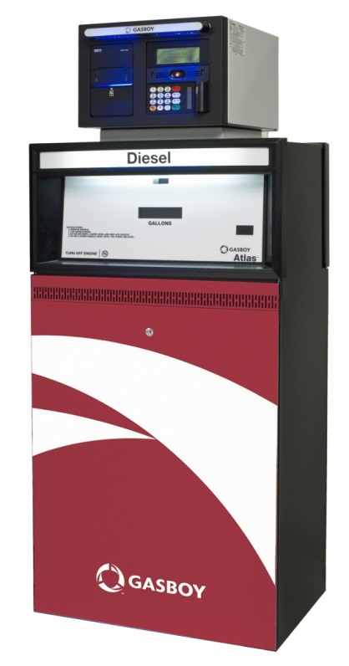

TopKAT PLUS demands little, but delivers a lot. It enables you to create a wide variety of customized restrictions, it delivers sophisticated reports, and it integrates seamlessly with your automatic tank gauge system. It can even deliver data to you anywhere in the world over the Internet. Track costs more precisely with a seamless connection to Gasboy Fleet Head Office. Collect data without slowing down your operation with support for multiple access technologies, including Web-based and contactless systems. Stay up and running 24-7 with lighted terminals and secured access for unattended sites.

TopKAT PLUS proves that sophistication can be simple. Order your Gasboy dispenser with TopKAT PLUS installed, and it goes to work; identifying every driver, monitoring every transaction, tracking every detail. No separate mounting base, no dedicated power lines. Just a steady stream of data that maximizes efficiency and keeps you in control.

**Meters/Registers  
MR 5-30 Mechanical Fuel Meter**[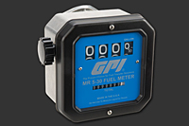](http://catalog.gpi.net/viewitems/fuel-meters/mechanical-fuel-meters-mr-5-30?&plpver=1001)

This aluminum meter is perfect for use with gasoline, diesel fuel and kerosene. Designed for high volume pumps up to 30 GPM.

**3 Wheel Mechanical, ¾” Meter, 5-20 GPM**

**807C**

The 807C Mechanical flow meter has a large easy to read display, flow ports can be positioned vertically or horizontally, UL/cUL listed, handles fluid of any viscosity, rated for Gasoline, Diesel, Kerosene, mineral spirits, Stoddard solvents and heptane. Fill-Rite meters provide precision and durability in a cost-effective design. The 807C is a 3 wheel mechanical meter designed for transfer pumps with a flow rate of 5 to 20 GPM. this meter has a 3/4" inlet and outlet.

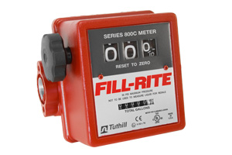

**4 Wheel Mechanical Meter, 1” Meter, 6-40 GPM  
901**

The 901 Mechanical flow meter has a large easy to read display, flow ports can be positioned vertically or horizontally, UL/cUL listed, handles fluid of any viscosity, rated for Gasoline, Diesel, Kerosene, mineral spirits, Stoddard solvents and heptane. Fill-Rite meters provide precision and durability in a cost-effective design. The 901 meter is a 4 wheel mechanical meter designed for transfer pumps with a flow rate of 6 to 40 GPM. this meter has a 1" inlet and outlet. Available in 1” and 1 ½”.

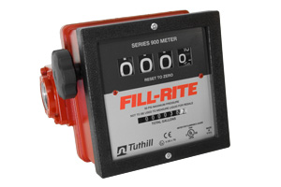

**Aluminum Nutating Disc Meter  
TN 740**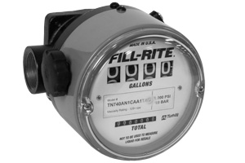

TN740 meters are excellent for heavy fuel oils, hydraulic oils and lubricating oils. This high pressure meter is ideal for use in automotive fluid distribution systems, lube trucks and similar service. Capable of handling up to 1000psi and 50,000cSt this meter has a large display for easy viewing.  
Nutating Disc technology perfect for non-custody transfer applications such as inventory control of refined petroleum products and non-corrosive chemicals.

**Digital Meters  
DR 5-30 Digital Fuel Meter**[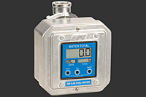](http://catalog.gpi.net/viewitems/fuel-meters/digital-fuel-meters-dr-5-30?&plpver=1001)

The rugged design protects the digital electronics that come programmed with seven different units of measure. Field calibration is easy from the front panel should you need flexibility. This versatile meter includes fittings that rotate and the meter cover can be turned too. Choose from three different sizes 3/4, 1 and 1 1/2 inch with either NPT or BSPP threads.

**Digital Meter, 1” inlet/outlet, 6-40 GPM  
900DB**

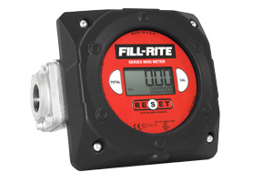

The 900DB, Digital Flow Meter has easy to read 4 digit LCD counter display. 6-40 GPM, +/- 1.25% accuracy. Measures in Gallons, Liters, Quarts, Pints, Ounces and User Defined Units. Battery Operated (2 AA batteries Included).

**LM50 Lube Meters**[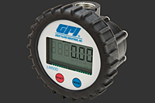](http://catalog.gpi.net/viewitems/fuel-meters/lm50-lube-meters-fuel-?&plpver=1001)

Choose from one of the latest positive displacement meters available from GPI. These compact meters are perfect for metering oil and provide exceptional reliability. Choose the LM50P when Pulse Out without Display meets your application. The LM50D model includes an easy to- read display. Both meters are designed with oval rotors for optimum accuracy.

**FM-300H Chemical Meters**

Most accurate and versatile agricultural chemical meter on the market. Factory calibrated for thin and medium to thick fluids, even oils.

* Flow range is 2 to 20 GPM (7 to 75 LPM)
* Nutating disc meter with electronic display.
* Typical accuracy: Factory Calibration is ± 2%. Field Calibration is ± 0.5%.
* Durable PBT Polyester construction.
* Keeps both batch and cumulative totals.
* For litre calibration, order (120000-2).

[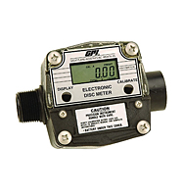](http://catalog.gpi.net/viewitems/chemical-and-water-meters/fm-300h-chemical-meters?&plpver=1001)

**Digital Display Meters  
01N Series Electronic Digital Meters**

Mount this meter on the end of a hose or on a pipe, in-line. The compact design with large display makes this meter handy and easy to read.

* Flow range for the 01 Series is 3 to 30 GPM (10 to 100 LPM).
* Typical accuracy is ± 2.5% (accuracy can vary ± 5%.)
* Powered by two AAA batteries that are simple to replace.
* Gallon and liter models available.

[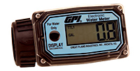](http://catalog.gpi.net/viewitems/chemical-and-water-meters/01n-series-electronic-digital-meters-fuel-?&plpver=1001)

**03N Series Nylon Electronic Digital Meters**

More accurate, more features. The 03 Series nylon meters are a step up from our basic 01 Series meters. These meters are factory calibrated but offer field calibration too.   
Models available:  
03N30GM 0.3 to 3 GPM (1 to 10 LPM)  
03N31GM 3 to 50 GPM (10 to 190 LPM)

* Two models available, low flow and 1 inch.
* Typical accuracy for Factory Calibration is ± 1.5%; for Field Calibration is ± 1%.
* Powered by lithium battery for long life.
* Displays in gallons or liters.

[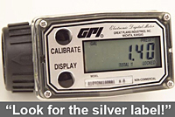](http://catalog.gpi.net/viewitems/chemical-and-water-meters/03n-series-nylon-electronic-digital-meters-fuel-?&plpver=1001)

**TM Series Water Meter**

This economy water flow meter is an ideal alternative to traditional water meters. The TM Series water meters offer flow rate and flow total indication that help monitor water flow in wastewater application, water treatment, and sub-metering application. The battery powered electronic display TM Series water flow meters are calibrated to read in gallons and liters per minute. These water flow meters also have two totals in which case one is resettable and the other gives you cumulative flow totals. These electronic water meters are available in 1/2 inch, 3/4 inch, 1 inch, 1-1/2 inch and 2 inch models.

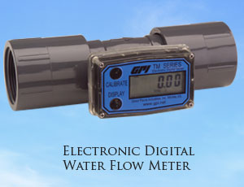

**Pressure Gauges   
Standard Dry Gauge**[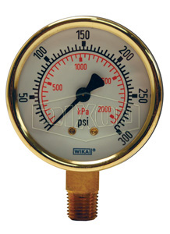](http://www.dixonvalve.com/files/product/images/large/brass_standard_dry_gauge_gbr300_color_lg_watermarked.jpg)

Available in 0-15 through 0-5,000 PSI. 2 ½” face. ¼“ lower mount. Brass Body. Other sizes and materials available.

**Liquid Filled Gauge**[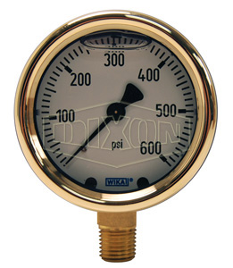](http://www.dixonvalve.com/files/product/images/large/brass_liquid_filled_gauge_glbr600_color_lg_watermarked.jpg)

Available in 0-15 through 0-5,000 PSI. 2 ½” face. ¼“ lower mount. Brass Body. Other sizes and materials available.

**Digital General Purpose Gauge**[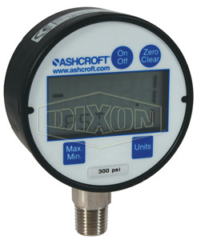](http://www.dixonvalve.com/files/product/images/large/1332446972general%20purpose%20digital%20gauge_dg300_color_lg_watermarked.jpg)

Available 0-30 through 0-10,000 PSI. ¼” lower. ½” face. General purpose digital gauges are suitable not only for dry air applications but other media as well. Gauge offers selectable units of measure so rather than purchasing one gauge for each unit of measure required, the solution is one gauge for multiple units of measure.

**Gauge Sticks**

**Sectional Gauge Sticks**

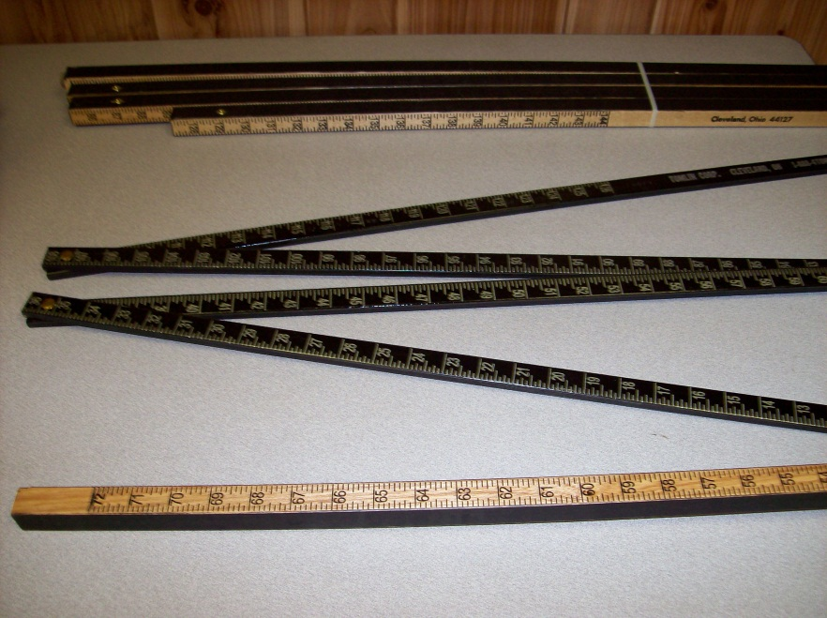

4 piece sectional gauge stick calibrated in inches to 12 feet. Can be shipped by UPS. Easily assembled with metal sleeve for superior stability.  
Also available in 2, 3, or 4 sections in lengths varying from 12 feet to 30 feet.

**Straight Gauge Sticks**

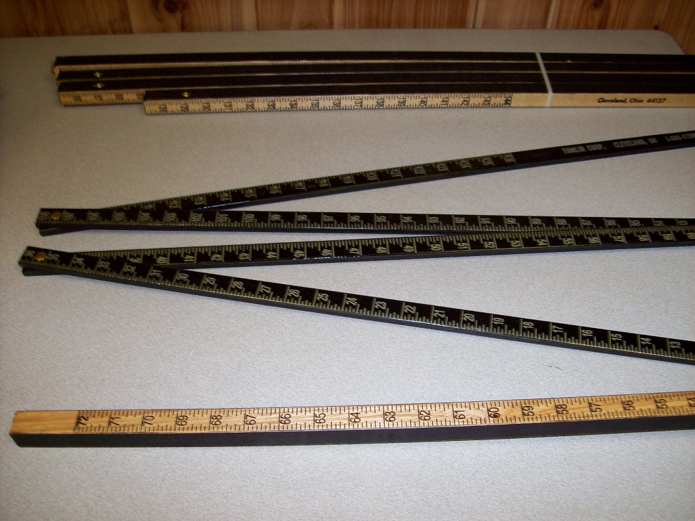

Available in a variety of lengths up to 18 feet calibrated in inches. Also available for 55 gallon drum. Calibrated in gallons for horizontal or vertical readings.

**Folding Gauge Sticks**

Available in 9 ft., 12 ft., and 15 ft. overall lengths.  
9 ft. Calibrated to 72”   
12 ft. Calibrated to 126”  
15 ft. Calibrated to 144”  
 Folds to 3 feet for storage and shipping. Permanent rivet in non-ferrous metal.

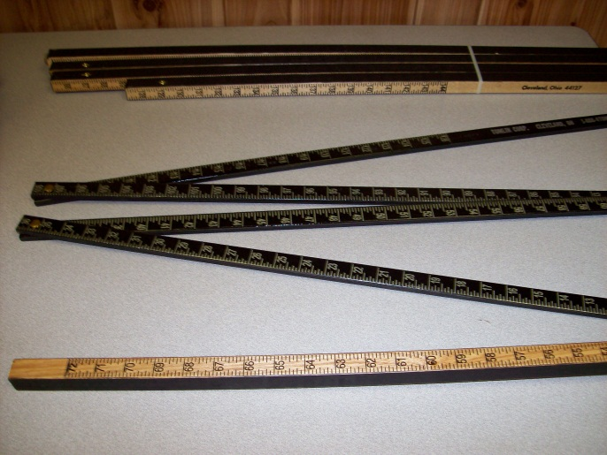

**Gauging Paste  
Sar-gel**

A thin layer of indicating paste is applied to gauge stick prior to placing the stick into the liquid in the storage tank. Observe the color of the paste upon the removal of the gauge stick to determine the presence of water or gasoline. Find water level in gasoline, jet fuels, fuel oils, oils and many solvents. Intersection line between white and red indicates water line in tank.

**Water or Gasoline Indicating Paste**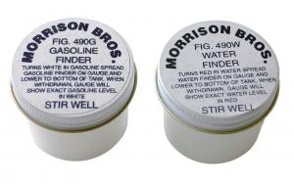

A thin layer of indicating paste is applied to gauge stick prior to placing the stick into the liquid in the storage tank. Observe the color of the paste upon the removal of the gauge stick to determine the presence of water or gasoline.  
Find upper level of gasoline in a storage tank. Turns white at and below the gasoline line.  
Find water level in gasoline and other hydrocarbon solvents. Turns red at and below water gas-solvent line.

**Kolor Kut Modified Water Finding Paste**



Paste changes from dark brown to bright red on contact with water. Phase separated alcohol solutions with as little as 6% water will turn the paste yellow. This product is designed for the use in reformulated and oxygenated fuel systems. After testing, it seems that alcohol or deicing agents in fuels have very little effect on the performance of the product. Packaged in 2.5 oz. tubes only.

**Samplers  
40800 Sampler  
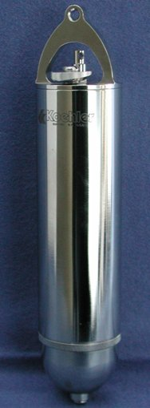**

Oil, Bacon Bomb, 16 ounces, 12 inch high x 2 ¾” diameter, plated brass. For collecting liquid samples from tanks. The bomb opens when the protruding plunger strikes the bottom of the tank and seals when bomb is raised. By attaching a cord to the upper end of the plunger, samples may be collected at intermediate levels. Less cord. Also available in stainless steel. Weight 5 lbs. Shipping weight 9 lbs.

**40810  
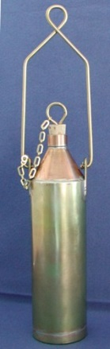**

Copper, Weighted, One Quart. For Sampling petroleum products in tanks and other vessels. Heavy copper flask or beaker with cork, weighted with 1/8” sheet lead for quick penetration. Dimensions are 3 ¾” dia. X 14” high, with brass bail raised, 17” high. Weight 4 lbs. Shipping weight 6 lbs. Two styles ¾” opening for light oils, 1 ½” opening for heavy oils. Less cord. Specify as follows below:   
**40810** ¾” Opening  
**40811** 1 ½” Opening

**40805  
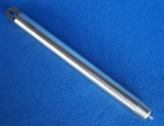**

Oil, Bacon, Pencil Type, 4 Ounces, 13-¼” long x 1-1/8” dia.   
Similar to the 40800 sampler, but made for use through small openings. Wt. 2 lbs.

**40821  
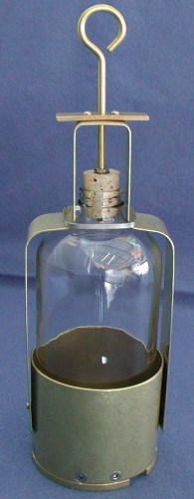**

Used for taking a running sample. Bottle and cord are not included. Specify narrow mouth plastic or glass bottle below.   
 **Samplers**  
**40821** Brass, 32 oz.   
**40822** Stainless Steel, 32 oz.   
**40823** Brass, 16 oz.   
**40824** Stainless Steel, 16 oz.  
 **Bottles**  
**13352** Bottle, 16 oz. , glass  
**13362** Bottle, 32 oz., glass  
**13652** Bottle, 16 oz., plastic  
**13662** Bottle, 32 oz., plastic

**Gauging Tape  
Fig. 464  
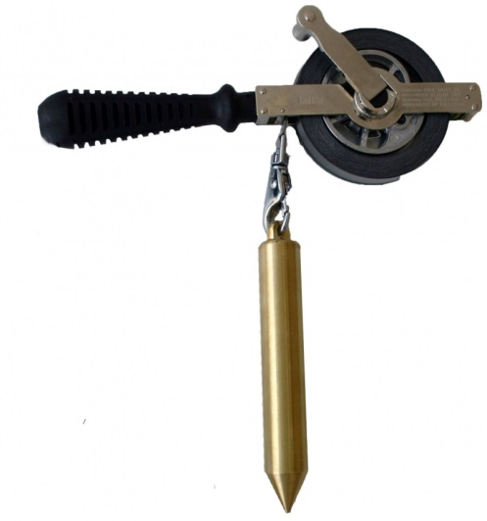  
Quik Thief  
72025**

Handheld gauging tapes are used to manually measure liquid levels in storage tanks.   
Features:  
Heavy duty frames designed for years of rugged use  
All frames include grounding straps  
Standard tapes read from left to right in 1/8” increments  
Plumb bob included in total measurement (Plumb bobs sold separately)  
Construction Details:  
Frame: Stainless steel  
Tape: Plated steel or stainless steel  
Plumb bob: Brass or stainless steel

This small thief is made entirely of brass and holds 100ml (cc) of fluid. It is used to gather small samples for centrifuging or chemical treating work.  
The opening at the top has a seat that seals tight, and a simple snap of the wrist allows the collection of samples at various levels. The marked rope allows you to open your thief quickly and collect your sample at the desired level.   
A 20 ft. marked rope comes with the thief, but ropes of any length can be made to your specifications.   
The dimensions of the Quik Thief are: overall length- 10 ½” , length from base to opening 7 ¼” , diameter- 1 ¼”, capacity100ml (cc), weight 1 ¼ lbs.

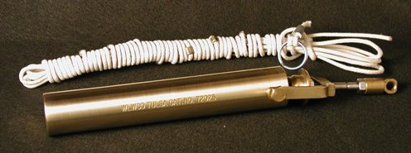

**Liquid Level Gauge and Sampler  
1100P**

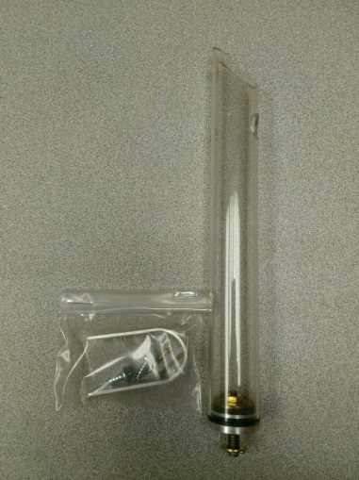

Universal 1100P allows bottom tank sampling. It features a clear plastic tube and complete assembly hardware (gauge stick not included). Overall height: 11 ½” Weight 0.2 lbs.

**Bailer  
PVCB15CR  
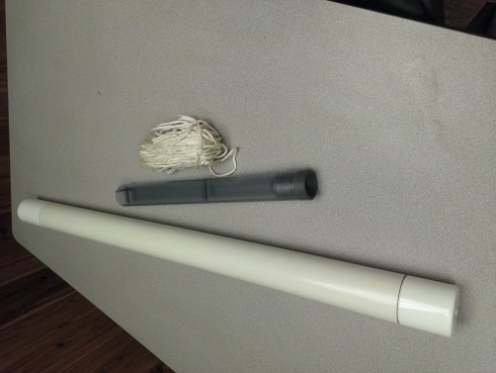**

Allows easy top sampling from monitoring wells for quick visual examination. Plastic construction with graduated panel. Complete with rope and carrying case. Overall height: 14 ½”. Weight: 1.9 lbs.

**Polyethylene Coliwasa Liquid Waste Sampler**

Minimizes operator’s exposure to potential hazards  
Designed to EPA standards  
High-density polyethylene construction, reusable  
Handles wide range of viscosity, corrosivity, volatility and solids content  
Simple design for rapid sample collection. Lower tube to desired depth. A light tug on cord while raising the unit sets the check valve, trapping the sample inside. Plastic rod inside tube allows sample to be collected at any depth. Dispenses easily into appropriate container. Holds approximately 3 ounces per foot.

